Trainity Assignment -2

First we will enter the commands for creating the database in the db fiddle once created we will use the database and by performing queries we will analyze it.

Here the database **ig_clone** has multiple tabes **like users, photos,comments , likes, follows, tags, photo_tags**

**THE VALUES INPUTTED TO THE TABLE ARE**

User table has the columns username and created_at

Photos table has the columns image_url and user_id

Follows table has columns follower_id and followee_id

Comments table has coloumns comment_text and user_id and photo_id

Likes table has columns user_id,photo_id

Follows table has columns

Tags table has columns tag_name

Photo_tags table has columns photo_id, tag_id

MARKETING

1. Find the 5 oldest users of the Instagram from the database provided

1. Find the users who have never posted a single photo on Instagram

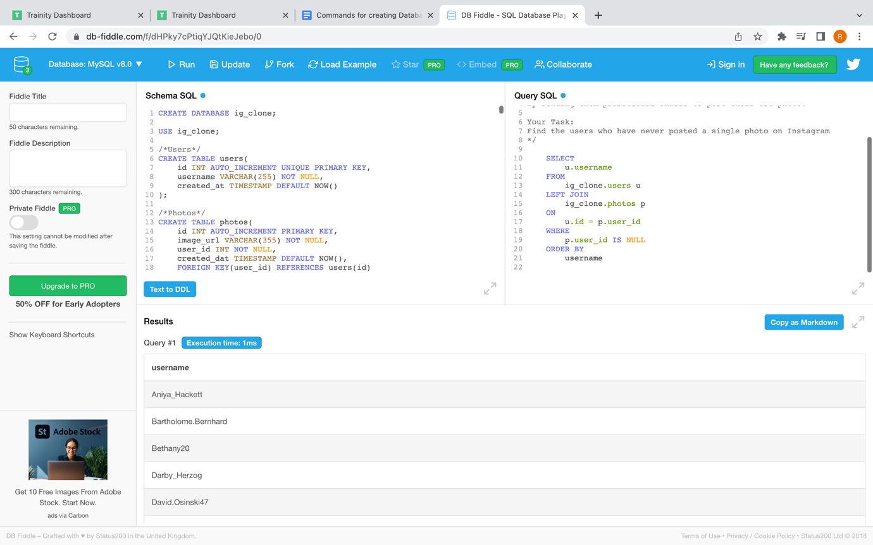

1. Identify the winner of the contest and provide their details to the team

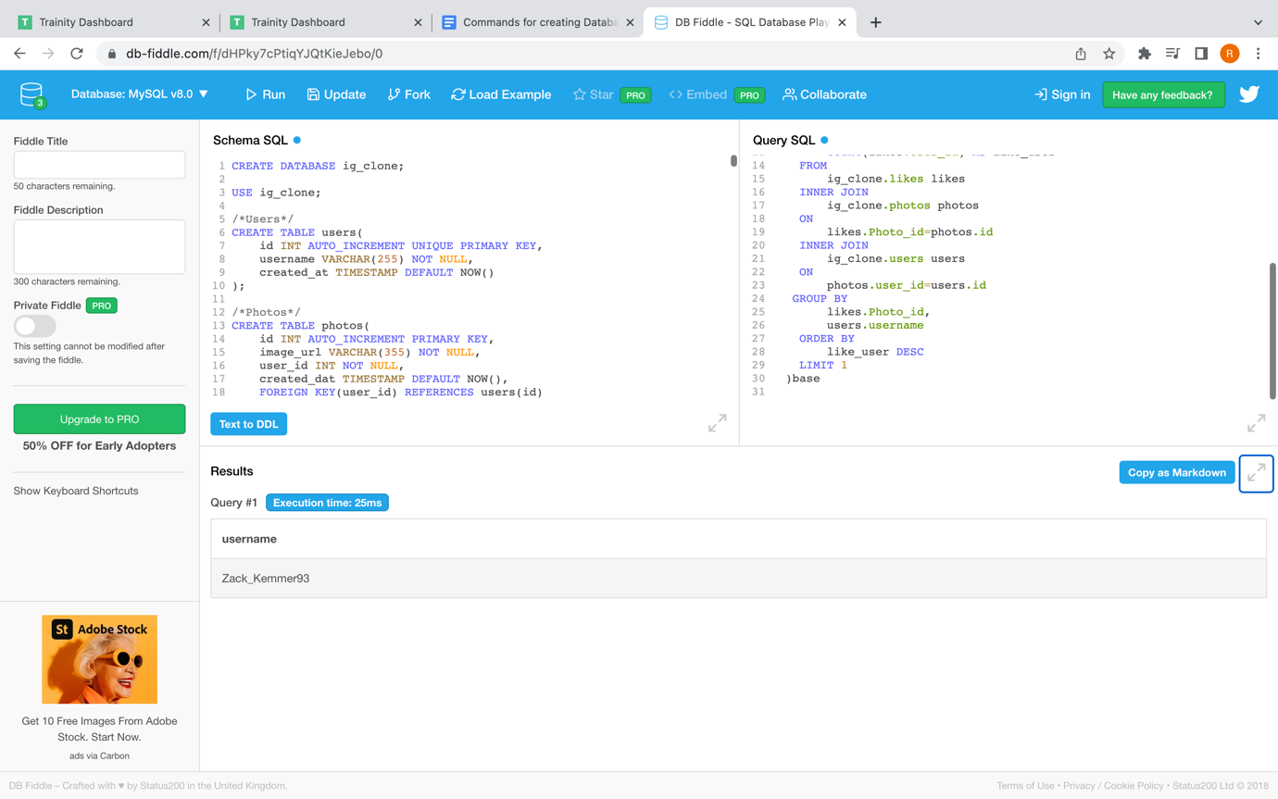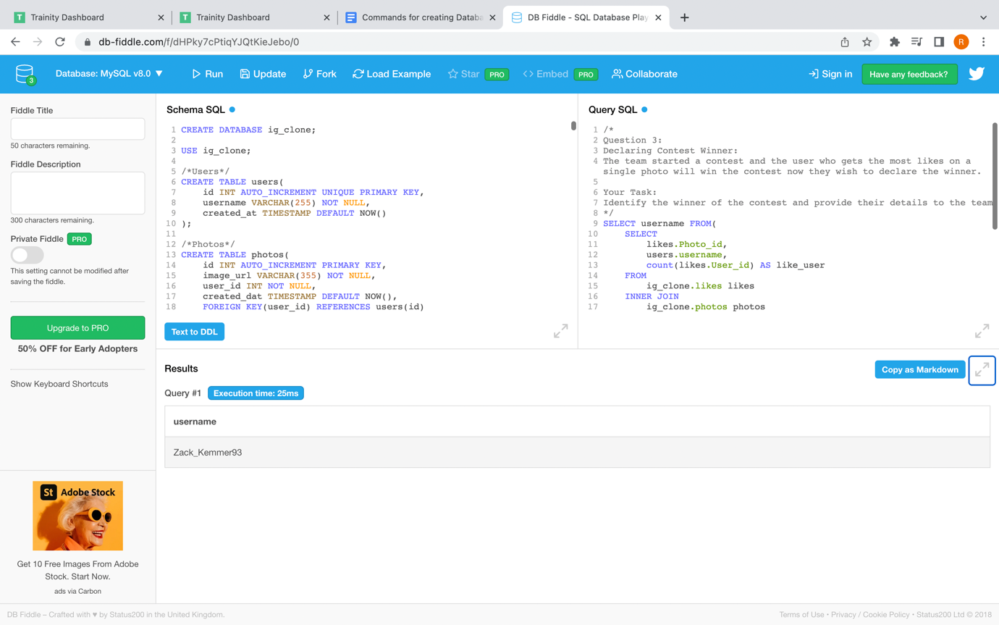

1. Identify and suggest the top 5 most commonly used hashtags on the platform

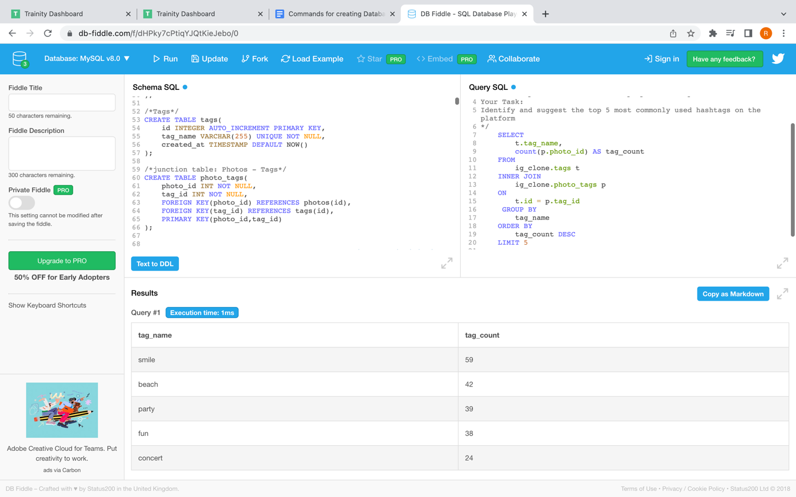

1. What day of the week do most users register on? Provide insights on when to schedule an ad campaign

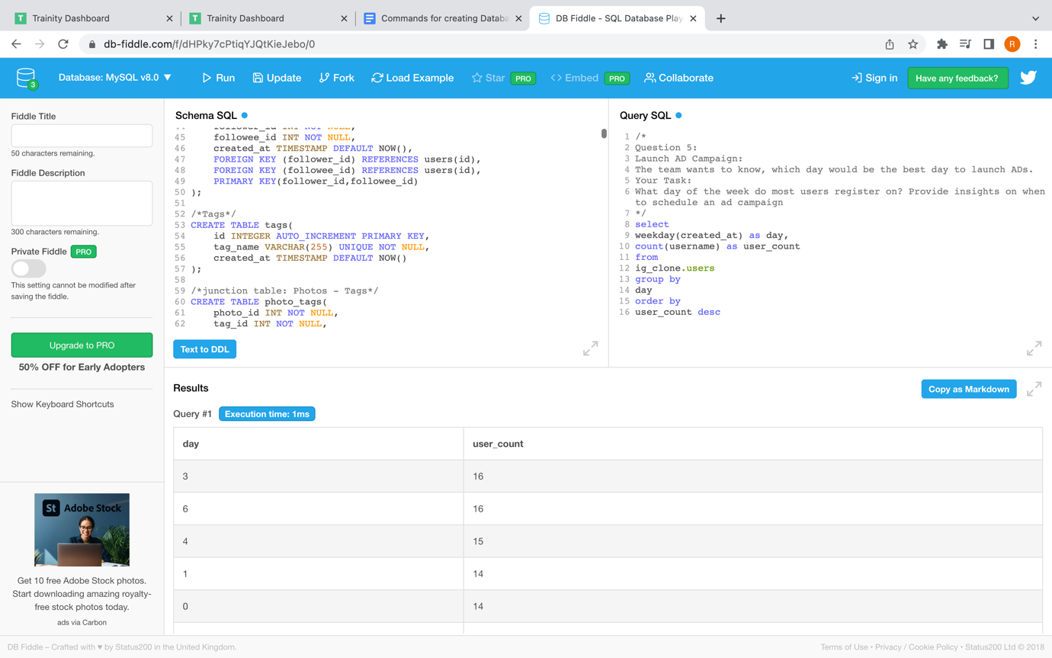

**B ) MARKETING**

1. Provide how many times does average user posts on Instagram. Also, provide the total number of photos on Instagram/total number of users

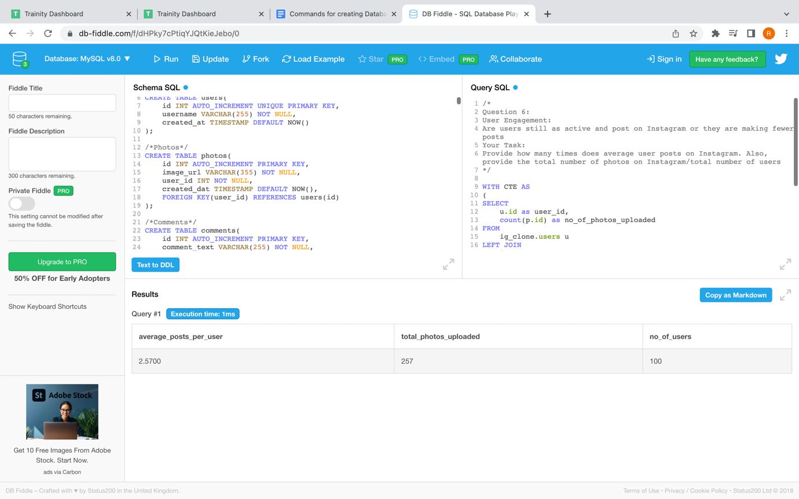

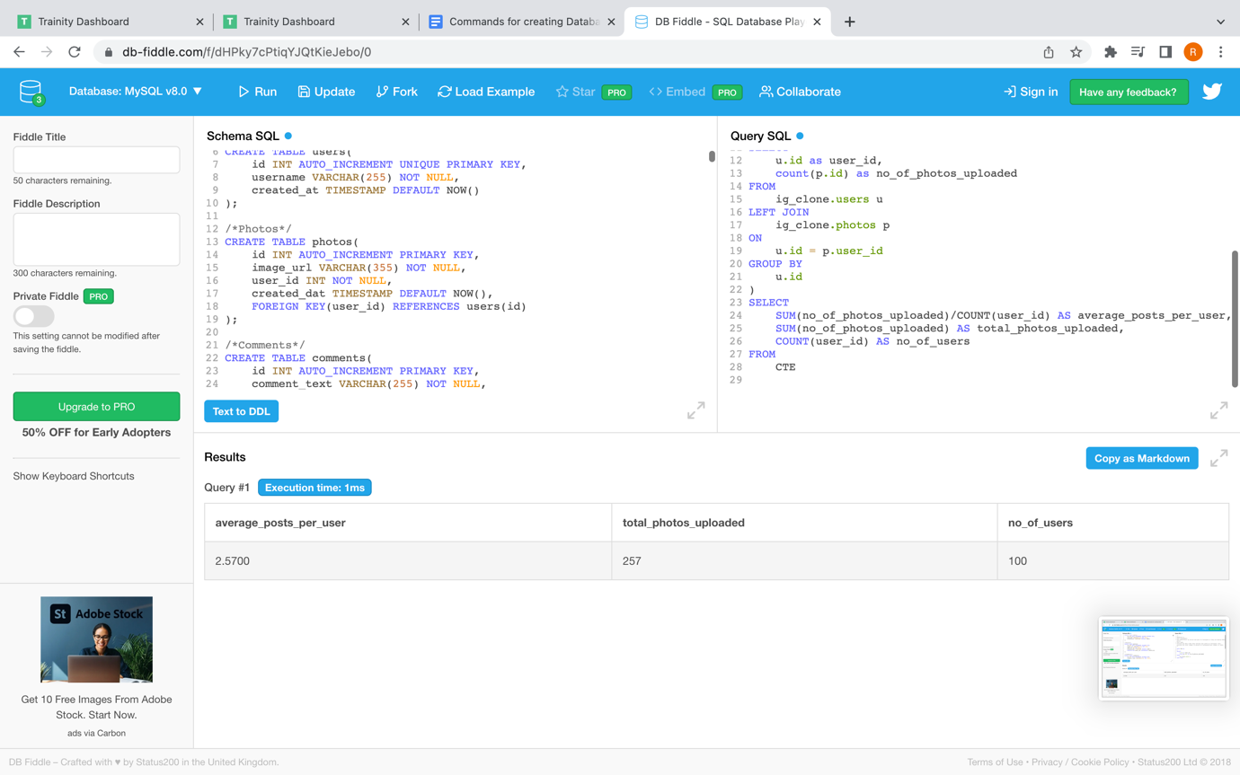

1. Provide data on users (bots) who have liked every single photo on the site (since any normal user would not be able to do this).

